**The accidental gangster**

He was a person who threw tantrum and liked people



Enjoys chocolate and syrup made of maple



People thought he was a triad

Even those who were

All he cared about going to college get the grades and have a nice car

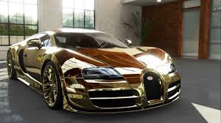

Not to mention some one to fall in love



Like to happy birds of dove

In the course of history because of his tantrum and academic prowess

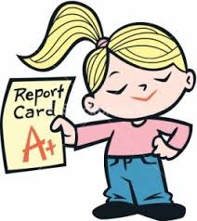

He got into many mess

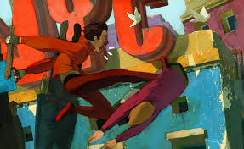

And image portrayed of a g a ka gangster

Done a bit of role play

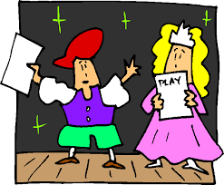

As when his friend colleagues

goes I know its your rep



Thought wow acted it though rep was true



Ha ha was part of mcd crew



The one who hated a person

He hated this person because his brain was built like that

Tried on people because he thought they were phat

Got it wrong as he was not all that

They say what goes round come round

A person who he upset made a big sound

There were strange and wonderful people in new planet and cities

Apart from people like this

Ones who can do magic so powerful and great they

In the time of affray

U stand still

Can’t move and then they kill

Wow

so hungry magic beef steak from a cow

If only yes

They can do that magic wand meat is here for them bless

Thannnn again order a takeaway

And like magic we eat whatever we want and here when we say